Unit 4 Tectonic Activity and Hazards Preparation February 2012

Advance Information
Explore the range of factors that make tectonic activity increasingly hazardous to humans and how the impact of disasters varies over time.
Research a range of social and economic impacts, resulting from seismic and volcanic hazards in contrasting locations, and how these may have varied over time.

Potential Questions

It is not the frequency of tectonic hazards that is increasing, but rather our awareness of them. Discuss

Critically examine the view that tectonic hazards appear to be occurring with increasing frequency and impact.

Tectonic activity is poses varying degree of challenge, and the severity and frequency of these impacts is changing over time. Discuss.

Assess the factors that are making tectonic increasingly hazardous, and examine the variation in their impact over time.

Key Areas to explore

- The evidence about whether tectonic hazards are increasing in frequency, magnitude and impact.

- Detailed evidence about the challenge and impacts of tectonic hazards – 2 x volcanic and 2 x earthquake hazards at different levels of development.

- Any available evidence about the challenge and impacts of tectonic hazards – 2 x volcanic and 2 x earthquake hazards over time. For example, how has the impact of the Haitian Earthquake or Japanese Tsunami varied since the event happened.

- The main factors that influence the changing impact:
- rising public awareness;
- changing demography especially rapid urbanization;
- improved prediction technology and responses;
- climate change;
- level of development;
- building construction and infrastructure.

- A clear idea about whether the root causes of trends in tectonic hazards lie within the human or natural domain.

“There is no such thing as a tectonic disaster, only a tectonic hazard. Disaster risk reduction is about human choices.”
(UNISDR, 2011)

“There are more than 1500 volcanoes potentially, active in the world and more than one million volcanic vents under the sea; about 50-60 volcanoes erupt every year worldwide.

Earthquakes are the natural hazard that causes most deaths per event. According to CRED between 1988 and 2007, more than 495 000 people died in earthquakes and approximately 3 billion people live in regions prone to earthquakes.”
(UNISDR, 2011)

By 2050 global levels of urbanization will reach 70% of the world’s population. As a result recent studies show that the number of people living with the threat of earthquakes and cyclones in cities could triple by 2050.
(UNISDR, 2011)

The recent annual death toll from earthquakes has been more than 75 000 higher than in any comparable period in the last century, and shows that the number of earthquakes causing significant human and economic loss has increased since the 1970s. This is at the same time as the annual frequency of earthquakes remaining within the ‘normal’ limits of expected seismic activity.
(Spence et al., 2011)

Task 1:

Develop some useful context and background (‘BIG’ picture) about global trends in tectonic hazards:

Evidence about whether tectonic hazards are increasing in frequency, magnitude and impact.

Task 2: Complete this grid relating to evidence about trends in tectonic hazards.

Evidence | What do you notice?
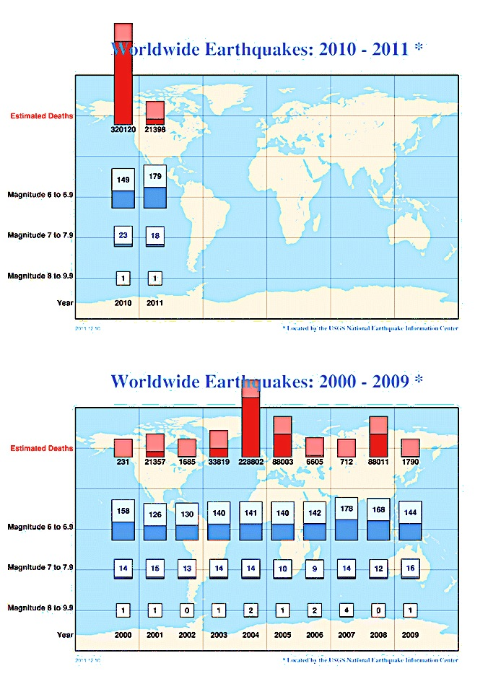  Source: USGS 2011 | What is the pattern in Earthquake activity?  What is the pattern in the frequency of different magnitudes?
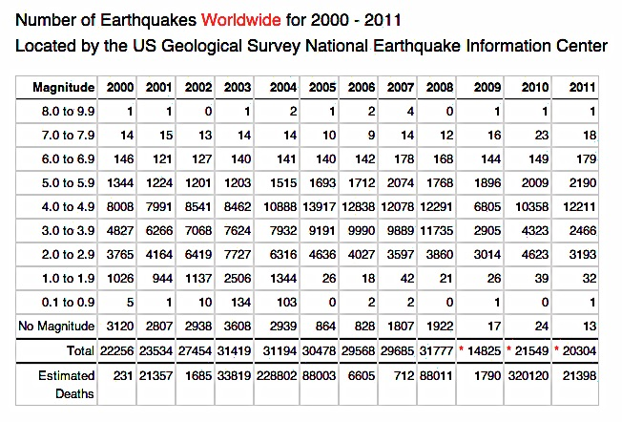  Source: USGS 2011 | Pattern in Earthquake activity?  Frequency of different magnitudes?
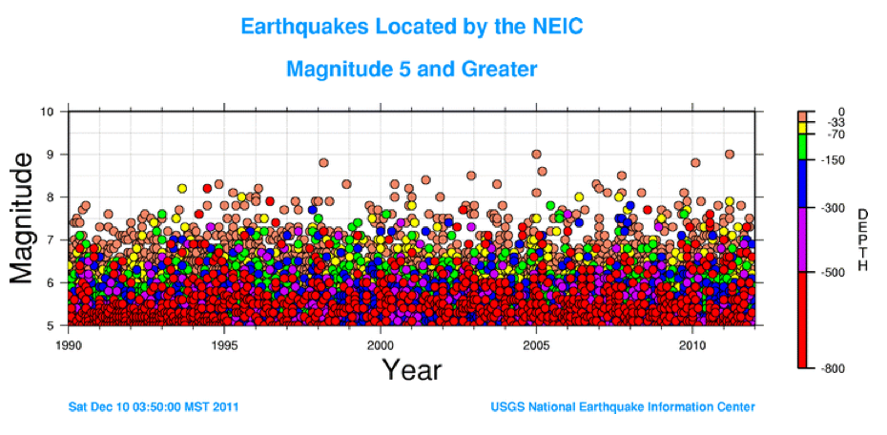
Source: USGS 2011
What is the general relationship between magnitude and depth over time?
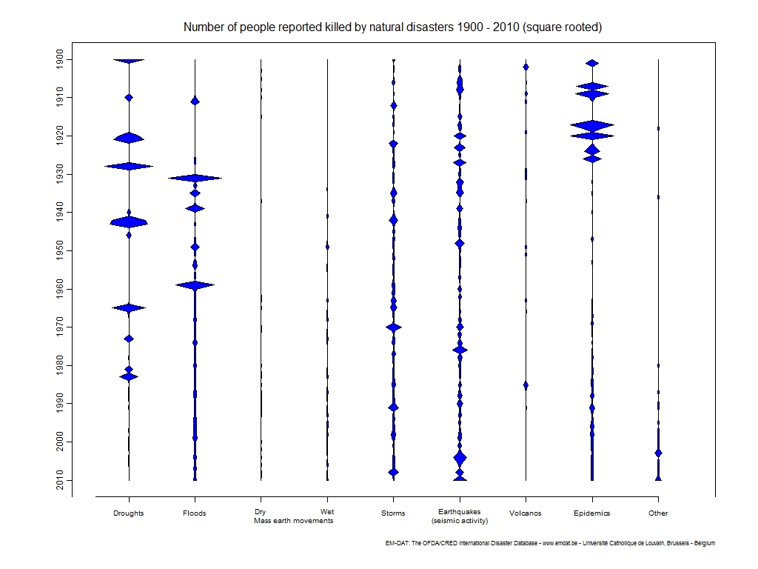  Source: EM-DAT |  | What do you notice about the pattern in tectonic hazards over time?  What do you notice about this pattern compared to other hazards?
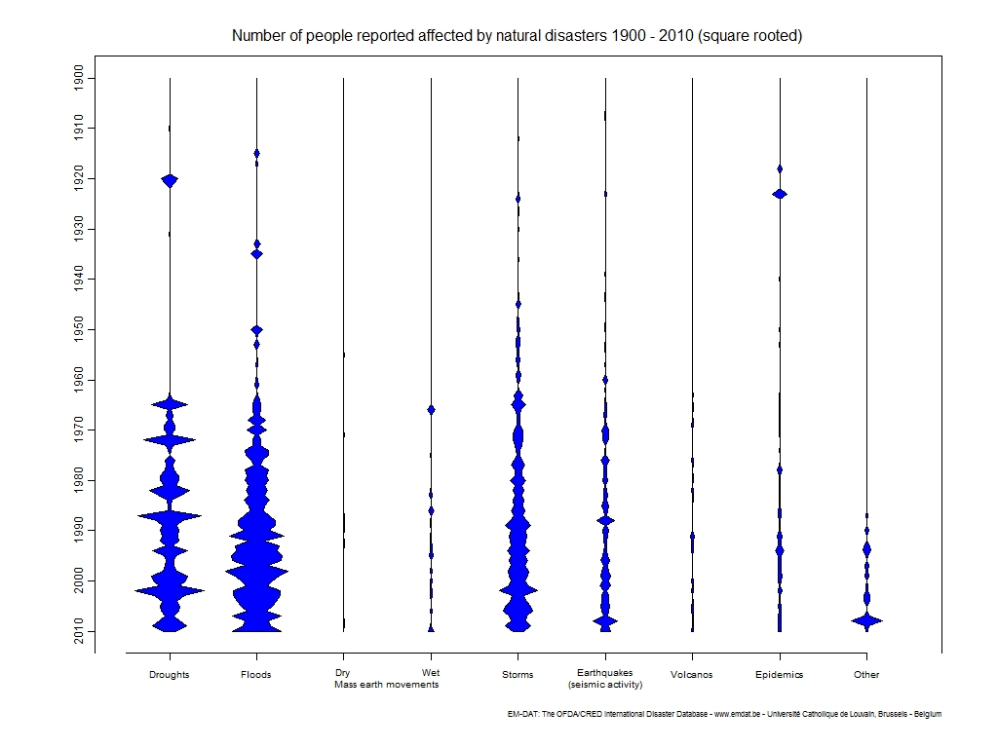  Source: EM-DAT 2011 |  | What do you notice about the pattern in tectonic hazards over time?  What do you notice about this pattern compared to other hazards?
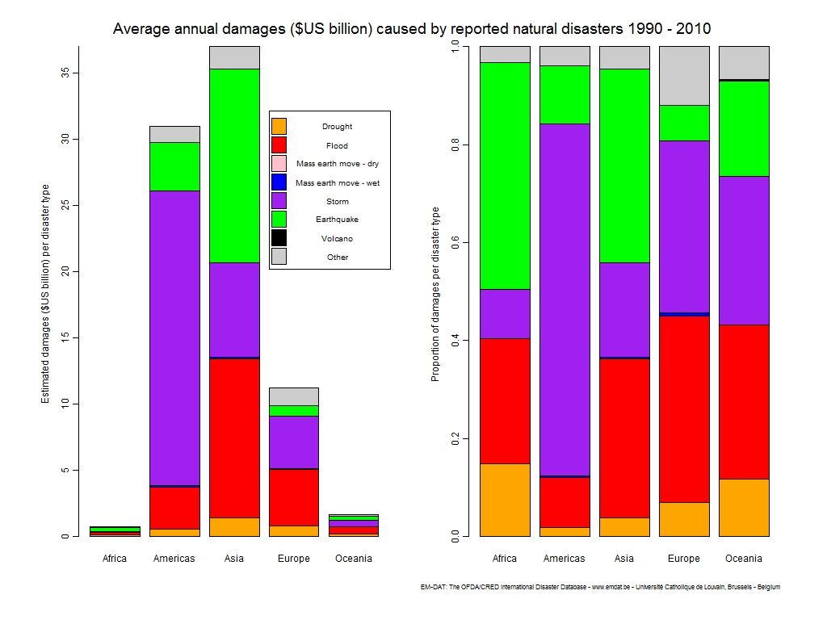  Source: EM-DAT 2011 |  | What do you notice about the pattern in tectonic hazards between places?  What do you notice about this pattern compared to other hazards?

What are the most important questions that this raises about the trends in tectonic hazards?
Think carefully about the patterns in frequency, magnitude, and impact that you have evidence of.

Task 3: Summarise the main impacts from Your Case Studies

Case Study | Main Socio-Economic and Physical Impacts | Evidence of Change over Time
Earthquake 1
Earthquake 2
Volcano 1
Volcano 2

Exploring the main factors influencing the trends in tectonic hazards.

Task 4: Factors influencing Trends in Tectonic Hazards

Factor/BIG Point | Evidence | Explanation
Rising population – particularly in urban areas.
Improved prediction technology and response planning.
Climate Change
Level of Development
Building construction and infrastructure
Rising public awareness

