Name | Mount Merapi – Volcano – April/may 2006.
Eruption. | In April 2006, increased seismicity at more regular intervals and a detected bulge in the volcano’s cone indicated that fresh eruptions were imminent. Authorities put the volcano's neighbouring villages on high alert and local residents prepared for a likely evacuation. On April 19, smoke from the crater reached a height of 400 meters, compared to 75 metres the previous day. On April 23, after nine surface tremors and some 156 multifaced quakes signalled movements of magma, some 600 elderly and infant residents of the slopes were evacuated.
Date of past Eruptions and information on them. | -There have been varied eruptions over the past centuries. Mount Merapi is a conical volcano located on the border between Central Java and Yogyakarta, most active volcano in Indonesia, erupted regularly since 1548. The name Merapi means Mountain of fire. Typically, small eruptions occur every two to three years, and larger ones every 10-15 years or so. Notable eruptions, often causing many deaths, have occurred in 1006, 1786, 1822, 1872 (the most violent eruption in recent history), and 1930—when thirteen villages were destroyed and 1400 people killed by pyroclastic flows.  -On the morning of the 24 November 1994, a lava dome with a volume of 2.6 million m³ collapsed over a 7 hour period, producing pyroclastic flows (Flowage of a mixture of hot gases and unsorted pyroclastic material that can move at a maximum speed of 100 miles an hour.) that travelled up to 6.5 km to the south. The flows killed 64 people in the Boyong valley close to the communities of Turgo and Kaliurang. Lahars (A flow of water-saturated volcanic debris down the slope of a volcano in response to gravity. A type of mudflow.) were also generated as a consequence of heavy rainfall falling on unconsolidated ash deposits. In response to the fatalities, a 10 km stretch of the Boyong river was evacuated, leading to 6,000 people being housed in temporary accommodation. In addition, a further 2,700 people from communities located at high elevations on the volcano were permanently resettled  -1998 Mount Merapi : volcano In Indonesia Mount Merapi erupts on July 13th sending ash two miles into the sky and hot lava down its slopes.  -1998 Mount Merapi : volcano In Indonesia Mount Merapi erupts the second time in eight days on July 20th forcing 2100 people to flee. A column of black ash shot up towering above, followed by the lava flows down the flanks of the mountain. Rains caused mudslides of the fresh laid ash.
Location and Cause | Mt Merapi is a strato volcano and has erupted because of the subducting oceanic fault underneath its plate causing buildup in the mantel. The heat and pressure build up in the mantel causes the upward force of gas, ash, and lava to violently erupt through the volcano. It is situated at a subduction zone, where the Indo-Australian Plate is sliding beneath the Eurasian Plate. It is one of at least 129 active volcanoes in Indonesia, part of the Pacific Ring of Fire – a section of fault lines stretching from the Western Hemisphere through Japan and South East Asia. Mount Merapi is a conical volcano located on the border between Central Java and Yogyakarta, most active volcano in Indonesia.  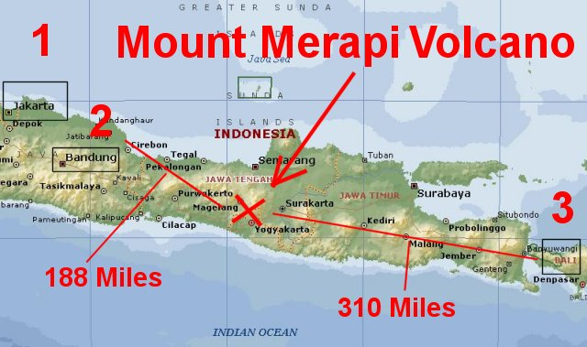  -The Indo-Australian Plate is a major tectonic plate that includes the continent of Australia and surrounding ocean, and extends northwest to include the Indian subcontinent and adjacent waters. Recent studies suggest that the Indo-Australian Plate may be in the process of breaking up into two separate plates due primarily to stresses induced by the collision of the Indo-Australian Plate with Eurasia along the Himalayas. ^{[1]} The two protoplates or subplates are generally referred to as the Indian Plate and the Australian Plate. (http://en.wikipedia.org/wiki/Indo-Australian_Plate)  -The Eurasian Plate is a tectonic plate which includes most of the continent of Eurasia (a landmass consisting of the traditional continents of Europe and Asia), with the notable exceptions of the Indian subcontinent, the Arabian subcontinent, and the area east of the Chersky Range in East Siberia. It also includes oceanic crust extending westward to the Mid-Atlantic Ridge and northward to the Gakkel Ridge. (http://en.wikipedia.org/wiki/Eurasian_Plate)  The collision between the Eurasian Plate and the Indian Plate, that forms the Himalayas, is convergent. – Meaning that In plate tectonics, a convergent boundary or convergent plate boundary, also known as a destructive plate boundary (because of subduction), is an actively deforming region where two (or more) tectonic plates or fragments of lithosphere move toward one another and collide. As a result of pressure and friction and plate material melting in the mantle, earthquakes and volcanoes are common near convergent boundaries.  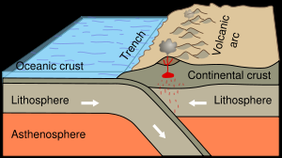
Effects on landscape and relief of land | Direct Volcanic eruptions : In may 2006 a shift to alert status (Shift to alert status was because an increase in seismic activity was recorded on Mt. Merapi.) meant that villagers stayed in evacuation shelters at night. Local population is expected to experience several eruptions during their lifetimes.  Second type of disaster, more important, volcanic debris flows (lahar) and flooding with much sediment. This type of disaster is caused by unstable debris that accumulates on the uppoer slopes of the mountain. E.G. Heavy rainfalls in 1982, a debris flows of old lahar deposits travelled 20 Kilometres down the mountainside and killed 80 people. Usually occurs during rainy season, people more prepared in recent years.  Mount Merapi eruption. By early May, active lava flows had begun. Some 17,000 people were evacuated from the area when lava flows begun to be constant on May 11. On May 27 2006, a 6.2 magnitude earthquake struck roughly 30 miles southwest of Merapi, killing 5,000 and leaving at least 200,000 people homeless in the Yogyakarta region, as lava and superheated clouds of gas poured repeatedly down the upper slopes.
Country Profile | - Full name: Republic of Indonesia  - Population: 234.3 million (UN, 2008)  - Capital: Jakarta  - Area: 1.9 million sq km (742,308 sq miles)  - Major languages: Indonesian, 300 regional languages  - Major religion: Islam  - Life expectancy: 69 years (men), 73 years (women) (UN)  - Monetary unit: 1 rupiah (Rp)  - Main exports: Oil and gas, plywood, textiles, rubber, palm oil  - GNI per capita: US $1,650 (World Bank, 2007)  - Internet domain: .id  - International dialling code: +62  - GDP : Indonesia $2,246  - Total adult literacy rate (%), 2000-2007 – 91%.  (http://news.bbc.co.uk/1/hi/world/asia-pacific/country_profiles/1260544.stm)  GDP – real growth rate : 6.3%.  (http://www.indexmundi.com/indonesia/gdp_real_growth_rate.html)
  Year | GDP - real growth rate | Rank | Percent Change | Date of Information
  2003 | 3.50 % | 83 |  | 2002 est.
  2004 | 4.10 % | 75 | 17.14 % | 2003 est.
  2005 | 4.90 % | 87 | 19.51 % | 2004 est.
  2006 | 5.60 % | 77 | 14.29 % | 2005 est.
  2007 | 5.50 % | 82 | -1.79 % | 2006 est.
  2008 | 6.30 % | 71 | 14.55 % | 2007 est.
Cost to  country of volcano | There could be profound effects on soil fertility. 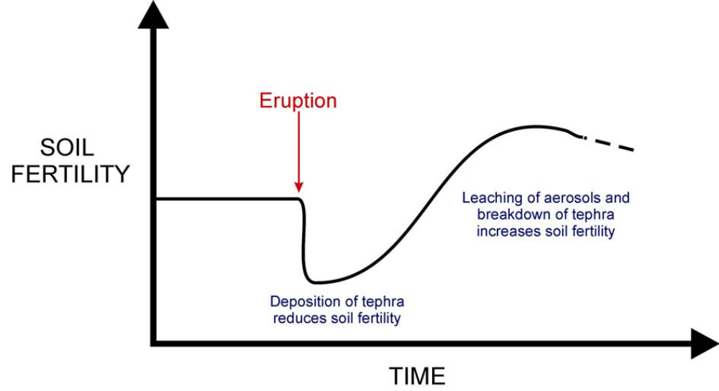  With all the subsistence farming that happens in this part of Indonesia this could have a very bad effect, this is why farmers must find ways to preserve their crops after an eruption has occurred.  Several different approaches being used to attempt to mitigate the impacts of ashfall on crops. The most effective method was washing crops in water immediately after harvest. This worked very well for cabbages when washed in irrigation channels immediately after harvest. However, in general, it is very difficult to clean ash from leaves, and it becomes more difficult as more time elapses from deposition of the ash.  Rinsing with water is the best way to remove ash, but frequently is not possible because of  water shortages. Shaking crops to remove ash was a common practice, but is time consuming and does not completely remove ash  The agricultural sector was very vulnerable to the impacts of the 2006 Merapi eruption, although this vulnerability was not uniform across the sector and indeed in some instances a high degree of resilience was observed on many farms (especially those growing rice). Access to a reliable water supply appeared to be a key factor in overall farm resilience, although a diverse selection of crops grown on each farm also increased resilience.  There are not only effects on Agriculture – there are also profound effects on infrastructure.  The only major damage to buildings sustained during the 2006 eruption of Merapi was  caused by the large block and ash flow that occurred at 3 p.m. on 14 June. Buildings in the  path of the flow were completely destroyed. – There are also disruptions in electricity, telecommunications and air travel.
Response and capacity to cope | There is a system that gives different levels of alertness as a response system to Merapi. (http://wwww.reliefweb.int/rw/RWFiles2006.nsf/FilesByRWDocUnidFilename/VBOL-6Q4J3E-who-idn-22may.pdf/$File/who-idn-22may.pdf)  Level of Alertness Terms Indications  Level 1 Normal activity - Basaltic activity.  - There is no magma pressure indication.  Level 2 Cautious - Volcanic and seismic activities are at an  increment above normal level.  - Low activity caused by magma, tectonic, and  hydrothermal power.  Level 3 Alert - Intensive seismic activity. All data show that it  will proceed to eruption or to volcanic disaster.  - If the tendency is for activity to increase to the  next level, eruption will be happen within 2  weeks.  Level 4 Beware - It will erupt or is erupting or in critical  condition which can caused volcanic disaster in  just minutes.  - The crater eruption has started with ash and  smoke.  - It will explode in 24 hours.  Capacity To Cope around Merapi.  Over the years the capacity to cope around Merapi for villages and the communities has increased, with more advanced technology increases in seismic activities can be detected earlier leading to evacuations being swifter.  There is a Volcanic Disaster countermeasure Project:  Sabo facilities (Sabo works mainly involve the construction of sabo dams (check dams) in remote mountain areas. Because of the principal locations of such works, the general public does not often see them and the necessity for and role of sabo works are seldom understood. If devastated mountain land is left unattended, however, the sediment discharged from this land raises the riverbed in the lower reaches, thus increasing the likelihood of flooding and sediment disasters.) at Mr Merapi consist of soil erosion and debris control structures , different types of Dams + dikes.  Sabo facilities were constructed in the areas adjacent to Mt Merapi ni order to prevent or mitigate the damage caused by disasters. Sabo facilities were constructed in three phases, first stage enabled by national budget, second by Japanese funding (aid in 1985-1992). Facilities acquires in phase II were constructed due to a change in the general direction of eruptions towards the southern and western flanks of Mt. Merapi. The achievement rate of the sabo facility is 70%. There have been NO fatalities or serious damage to property or agricultural land since 1994, even though debris flows have occurred every year. Prior to the scheme in place 47% of residents were worried about debris flow, this number has dispersed.  This shows that the risk has been lowered significantly and that the schemes put in place have had a profound effect.  2006 Eruption, Mt. Merapi. (http://en.wikipedia.org/wiki/Mount_Merapi#2006_eruption)  In April 2006, increased seismicity at more regular intervals and a detected bulge in the volcano's cone indicated that fresh eruptions were imminent. Authorities put the volcano's neighbouring villages on high alert and local residents prepared for a likely evacuation. On April 19, smoke from the crater reached a height of 400 meters, compared to 75 metres the previous day. On April 23, after nine surface tremors and some 156 multifaced quakes signalled movements of magma, some 600 elderly and infant residents of the slopes were evacuated.  By early May, active lava flows had begun. On May 11, with lava flow beginning to be constant, some 17,000 people were ordered to be evacuated from the area and on May 13, Indonesian authorities raised the alert status to the highest level, ordering the immediate evacuation of all residents on the mountain. Many villagers defied the dangers posed by the volcano and returned to their villages, fearing that their livestock and crops would be vulnerable to theft. Activity calmed by the middle of May.  Title of a newspaper article “MERAPI'S ERUPTION EXPECTED” – Can be seen from this “EXPECTED” that their capcity to cope has increased in recent times, the fact that it was expected shows that they will have had time to evacuate areas.  Impacts of the 2006 eruption on other factors : Agriculture received the most damage of any economic sector, mostly due to the close  proximity of a significant number of farms to Merapi volcano. Impacts on crops varied with  ash thickness, as well as by crop type and plant maturity. Up to 100% of crops were lost in  some locations. Despite their relatively small size, the 2006 eruptions of Merapi caused two deaths, the destruction of most of the village of Bebeng/Kaliadem, the displacement of tens of thousands of people, and significant impacts on the agriculture of the region  http://www.searo.who.int/EN/Section1257/Section2263/Section2337_12583.htm  Shows that in june 2006 there was An earthquake of magnitude 6.2 on the Richter scale, but there was no Eruption, but the quick reaction of health services such as the WHO it shows that there is a very good response in place in the case that a volcanic eruption does take place, the WHO staff have gone to Mount Merapi and report that there is no serious eruption. – Other factors can contribute towards the eruption of mount Merapi. The land use around Merapi can be described as high-intensity, low-technology, subsistence tropical agriculture. Farm sizes are typically between one and two hectares, and may support families ranging from an elderly couple to a large  extended family of up to ten people. The Yogyakarta region has a year-round tropical  growing season that is typically divided into a wet season (October to March) and a dry  season (April to September).  What can be done ? - Agricultural experts expected there to be some adjustment to planting strategies, with  farmers moving towards planting more resilient plants in the short term.  In many areas, local farmers had started to plant more  resilient crops such as carrots, potatoes, onions and cabbage. Most farmers appear to  have adopted a wait-and-see attitude in response to the ashfall, and were following  normal crop rotation practices rather than abandoning crops and ploughing them under  to start again.  Date Time Event – for 2006 eruption. – Shows many organisations such as Merapi volcano observatory that are willing to help and track events that are happening to provide up-to-date info on eruptions.  25 April - Merapi Volcano Observatory (BPPTK) reports 198 multi-phase (MPT)  earthquakes, 4 shallow volcanic tremors (SVT), and one tectonic quake (TT)  26 April - BPPTK reports 57 MPTs, one SVT  3 May - BPPTK reports 84 MPTs, one SVT, and 4 discharges  4 May 02:00 Lava erupted from summit  7 May - 133 MPTs, 88 TT, and one SVT  8 May 0:00-06:00 One SVT, 34 MPTs, 29 TTs  9 May - 6 VTs, 142 MPTs, 152 RFTs.  10 May 0:00-06:00 One SVT, 123 MPTs, 88 rock fall tremors (RFT), and 4 TTs. Evidence of  new growing lava dome at summit reported  12 May - 90 MPTs, 214 RFTs, 4 TTs, 11 pyroclastic flows (PF) max. 1.6 km down  upper Krasak and Boyong Rivers, lava flows (LF) down same drainages to  1,500m from summit  13 May 0:00 and  06:00  27 MPTs, 24 RFTs, and 14 PFs of uncertain distance. BPPTK recommends  communities within 8 km of the crater on the south-southeast sector  evacuate, along with those within 10 km of the crater on the southwest-west  side and those within 8 km on the western flank.  14 May 0:00 to 06:00 23 ash/steam clouds erupted once every 15 minutes  4/5 June unknown Geger Boyo collapses  13 June - Alert level lowered from 4 (caution) to 3 (alert)  14 June ~12:00 Small dome collapse flow causes renewed evacuation of Kaliadem and  surrounds  14 June ~15:00 Dome collapse, block and ash flow down Woro valley onto Kaliadem village.  Two men were killed in a bunker where they tried to escape the flow. Water  pipes were severed, cutting off water to 12,000 people. The alert level was  raised to 4 (caution)  22 June to 5  July  - Small dome-collapse block and ash flows continue, but decrease in intensity  and frequency  12 July - Alert level lowered from 4 (caution) to 3 (alert).  12 July to 25th  August  - Continued decrease in eruption activity  By October 1 Return to baseline Alert Level  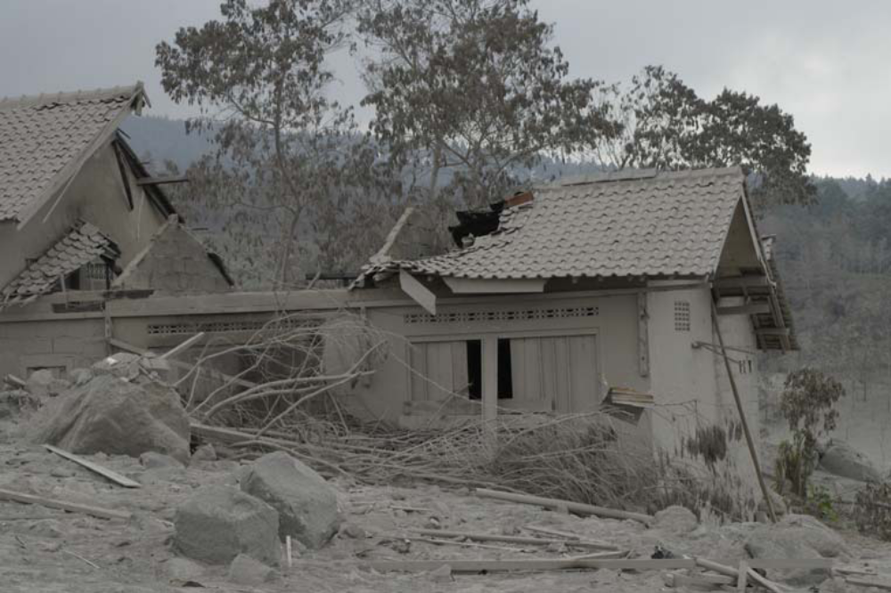  It can be seen that most of the damage done by the 2006 eruption was to buildings, only two lives were actually lost.  Social impacts and why they were limited! :  In early April 2006, the Indonesian government began logistical preparations for a volcanic  crisis as volcano-seismic activity at Merapi began to increase. The evacuation of the most at risk communities began on 3 May, in advance of the alert level system reaching its highest  level on 13 May. On 3 May, several hundred pregnant women and elderly people were  evacuated at 10 a.m., and in the second phase, children were evacuated at 4 p.m.  By 13 May, medical teams had been placed in strategic locations, and evacuation routes had been established (WHO Emergency Situation Report, 13/05/06). The Merapi Volcano  Observatory (known locally as BPPTK) encouraged evacuation of communities on the  western sector of the volcano within 8 km of the summit; on the southwest-west sector within  10 km, and on the south-southeast sector within 8 km of the summit (S. Bronto, pers comm.). Large-scale evacuation took place following the announcement, and the Indonesian Red Cross reported that by 13 May, 6942 people had been evacuated.  There were also camps that people could stay in that had been set up by the Red cross and the government, with aid from WHO and other such organisations and coming in from across the border from countries such as China. – all this did provide an economic strain.  International aid!  JAKARTA: The United States has provided an additional US$50,000 to help evacuate people from the slopes of the rumbling Mount Merapi, bringing its total assistance package to $100,000.  The money will help pay for officials to evacuate villagers from the slopes of the volcano and buy and transport blankets, tents, plastic bags and water to evacuation centers, USAID said in a statement.  The U.S. Geological Survey, through the Volcano Disaster Assistance Program, has also provided technical support and training to local Indonesian volcanologists along with special instruments to detect volcanic activity, the agency said.  (http://www.thejakartapost.com/news/2006/05/19/more-us-aid-merapi-evacuees.html)  Taken from http://www.channel4.com/news/articles/world/second%20wave/165300 - Channel 4.  More international aid is arriving in Indonesia to help victims of the Java earthquake - which has claimed more than five thousand lives.  Twenty two countries have answered Indonesia's call for help - offering aid, money and supplies for the tens of thousands of people left homeless - in the path of the country's most active volcano.  earlier there were warnings the effects of the quake may trigger an eruption of a nearby volcano.  Mount Merapi has been belching gas and lava for weeks, but seismologists say its activity has increased threefold since the quake at nearby Yogyakarta.  National and international aid.  Java volcano increases activity  Indonesia's Mount Merapi has been showing increasing activity, emitting large gas clouds and sending more than 15,000 villagers fleeing to safety.  The volcano has spewed out its largest gas cloud yet, experts said.  The Indonesian authorities are stepping up emergency preparations in case of a major eruption.  Scientists fear the volcano, which has been showing signs of erupting since early May, has been further destabilised by an earthquake nearby.  The quake, which struck near the ancient city of Yogyakarta two weeks ago, killed 6,200 people.  A major humanitarian operation is under way to help survivors, but local and international agencies are also aware they may have to face the possibility of a second disaster not far away, on the slopes of Merapi.  (http://news.bbc.co.uk/1/hi/world/asia-pacific/5058018.stm)
Glossary | Volcano Glossary  Active volcano: A volcano that is erupting. Also, a volcano that is not presently erupting but that has erupted within historical time and is considered likely to do so in the future.  Ash: Fine particles of pulverized rock blown from an explosion vent. Ash may be either solid or molten when first erupted.  Ashfall: Volcanic ash that has fallen through the air from an eruption cloud. A deposit so formed is usually well sorted and layered.  Ash flow: A turbulent mixture of gas and rock fragments, most of which are ash-sized particles, ejected violently from a crater or fissure. The mass of pyroclastics is normally of very high temperature and moves rapidly down the slopes.  Avalanche: A large mass of material or mixtures of material falling or sliding rapidly under the force of gravity.  Bomb: Fragment of molten or semi-molten rock, 2 1/2 inches to many feet in diameter, which is blown out during an eruption. Because of their plastic condition, bombs are often modified in shape during their flight or upon impact.  Central Vent: A central vent is an opening at the Earth's surface of a volcanic conduit of cylindrical or pipelike form.  Central Volcano: A volcano constructed by the ejection of debris and lava flows from a central point, forming a more or less symmetrical volcano.  -Cinder cone: A volcanic cone built entirely of loose fragmented material (pyroclastics.)  -Composite Volcano: A steep volcanic cone built by both lava flows and pyroclastic eruptions.  -Compound Volcano:A volcano that consists of a complex of two or more vents, or a volcano that has an associated volcanic dome, either in its crater or on its flanks. Examples are Vesuvius and Mont Pelee.  -Conduit: A passage followed by magma in a volcano.  -Crater: A steep-sided, usually circular depression formed by either explosion or collapse at a volcanic vent.  -Dome: A steep-sided mass of lava extruded from a volcanic vent. Its surface is often rough and blocky as a result of fragmentation of the cooler, outer crust during growth of the dome.  -Dormant volcano: The term is used to describe a volcano which is presently inactive but which may erupt again.  -Eruption: The process by which solid, liquid, and gaseous materials are ejected into the earth's atmosphere and onto the earth's surface by volcanic activity. Eruptions range from the quiet overflow of liquid rock to the tremendously violent expulsion of pyroclastics.  -Eruption cloud: The column of gases, ash, and larger rock fragments rising from a crater or other vent. If it is of sufficient volume and velocity, this gaseous column may reach many miles into the stratosphere, where high winds will carry it long distances.  -Eruptive vent: The opening through which volcanic material is emitted.  -Fault: A crack or fracture in the earth's surface. Movement along the fault can cause earthquakes or, in the process of mountain-building, can release underlying magma and permit it to rise to the surface.  -Fissures: Elongated fractures or cracks on the slopes of a volcano. Fissure eruptions typically produce liquid flows, but pyroclastics may also be ejected.  -Fumarole: A vent or opening through which issue steam, hydrogen sulfide, or other gases. The craters of many dormant volcanoes contain active fumaroles.  -Hot Spot: A volcanic center, 60 to 120 miles across and persistent for at least a few tens of million of years, that is thought to be the surface expression of a persistent rising plume of hot mantle material. Hot spots are not linked to arcs, and may not be associated with ocean ridges.  -Intensity: A measure of the effects of an earthquake at a particular place. Intensity depends not only on the magnitude of the earthquake but also on the distance from the epicenter and the local geology.  Intrusion: The process of emplacement of magma in pre-existing rock. Also refers to igneous rock mass so formed within the surrounding rock.  Lahar: A flow of water-saturated volcanic debris down the slope of a  volcano in response to gravity. A type of mudflow.  Lava: Magma which has reached the surface through a volcanic eruption. The term is applied to streams of liquid rock that flow from a crater or fissure.  Lava Flow: An outpouring of lava onto the land surface from a vent or fissure. Also, a solidified tongue like or sheet like body formed by outpouring lava.  Lava lake: A lake of molten lava, usually basaltic, in a volcanic crater or depression. The term refers to solidified and partially solidified stages as well as to the molten, active lava lake.  Magma: Molten rock beneath the surface of the earth.  Magma chamber: The subterranean cavity containing the gas-rich liquid magma which feeds a volcano.  Mantle: The zone of the earth below the crust and above the core.  Mudflow: A flowage of water-saturated earth material possessing a high degree of fluidity during movement. A less-saturated flowing mass is often called a debris flow. A mudflow originating on the flank of a volcano is properly called a lahar.  Pyroclastic: Pertaining to fragmented (clastic) rock material formed by a volcanic explosion or ejection from a volcanic vent.  Pyroclastic flow: Flowage of a mixture of hot gases and unsorted pyroclastic material that can move at a maximum speed of 100 miles an hour.  Repose:The interval of time between volcanic eruptions.  Rift zone: A zone of volcanic features associated with underlying dikes. The location of the rift is marked by cracks, faults, and vents.  Stratovolcano: A volcano composed of both lava flows and pyroclastic material.  Strombolian eruption: A type of volcanic eruption characterized by jetting of clots or fountains of fluid basaltic lava from a central crater.  Vesicle: A small air pocket or cavity formed in volcanic rock during solidification.  Volcano: A vent in the surface of the Earth through which magma and associated gases and ash erupt; also, the form or structure, usually conical, that is produced by the ejected material.  Volcanic arc: A generally curved linear belt of volcanoes above a subduction zone, and the volcanic and plutonic rocks formed there.  Vulcanian: A type of eruption consisting of the explosive ejection of incandescent fragments of new viscous lava, usually on the form of blocks.

