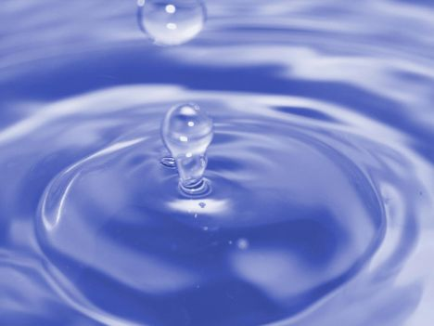 Middle East Case Study of Water Conflicts 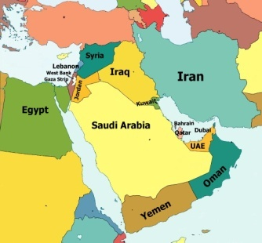

Why does it have water Problems

- 5% of the world’s population, but only 1% of the freshwater
- Population growth due to developing countries being in stage 2 or 3 of the Demographic transition model
- Increased affluence – demand in swimming pools and golf courses
- Irrigated farmlands – 89% of extracted water used on crops
- Depleting oil, meaning a lower income in the future, which means:
- Desalination cannot be paid for
- Imported food cannot be bought, so more grown in this region = increased water usage
- Rising young population, causing a rise in demand for water
- Many countries like Turkey and Israel depend on high yield crops for their wealth
- The water in the region is interconnected e.g Euphrates River = conflicts arise
- Climate change will make water shortages worse here
- Pollution of water sources e.g Gaza aquifer
- Salt water incursion due to over use of ground water stores e.g Israeli west coast
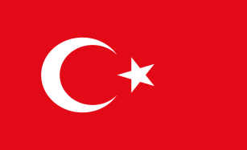
Conflicts in the Region

- Turkeys GAP Scheme

Aims
- $32 billion South Eastern Anatolia project to address droughts in Southern Turkey – effects major cities of Ankara and Istanbul
- Turkey aims to be the ‘breadbasket’ of the middle east – will therefore increase cash crops ( fruits, veg)
- Socio-economic development – create better education , healthcare, more jobs and so stop outmigration

What it will do
- 22 dams, 19 HEP plants, which produce 22% of turkey energy by 2010
- Irrigate over 1.7 million hectares and support 7% of the population
- South East Anatolia economy will grow by 400%
- Will dam the Euphrates and Tigris rivers

Concerns
- Syria and Iraq are unhappy as these rivers provide most of there water. This makes it a Geopolitical issue ( geography, economic and politics are interconnected)
- Ilisu Dam on the Tigris was proposed but they could not initially get funding due to the impact this was going to have ( World Bank, Uk Gov, Skansa Swedish TNC all pulled out – key players) because it was going to :
- Flood nearly 80,000 homes
- Displace tens of thousands of kurds
- Cause waterborne disease and Malaria to occur more
- Rotting veg would release methane and Co2 , so meaning it was damaging the environment

Future
- 2004 Ilisu Dam scheme amended ( still caused the displacement of the kurds). Funded by 3 companies combining
- Water was released to help out Syria, but not Iraq
- New plan is to create Cizre Dam – will take water out of the Tigris for irrigation and so annoy Syria and Iran

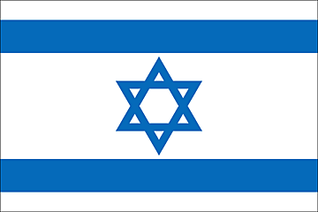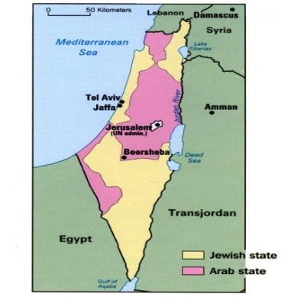

- Israel

Past

Israel had been in various conflict to ensure that water pathways (how water flow )are kept clear e.g :

- 1967 Six day war – an Israeli reaction to the Syrian attempt to divert the River Jordan. It resulted in Israel gaining - West Bank from Jordan, Golan Heights from Syria and the Gaza strip from Egypt
- 1994 Jordan Peace treaty – Israel led agreements over the sustainable use of the Yarmouk river
- 2000 Summit at Camp David in the US. Israel offered up land to the Palestinians, but not water
- 2004/5 Turkey agreed to ship water to Israel in return for high tech military support
- 2005/6 The Litani River disputes between Lebanon and Israel

Where they get water from

Current over consumption of water by the Israelis is not sustainable. They use 2200 billion litres a year, but naturally only have 1700. Water comes from:

- 25% natural
- The Sea of Galilee , fed by the river Jordan and tributaries in the Golan heights
- Mountain Aquifers – mainly in the West Bank. This is shared 80% Israel, 18% Palestine, 2% unavailable
- Coastal Aquifer – Israel controls 90% of this

Problems faced here:

- Syria want the boarders to be reinstated to before 1967 = Golan height would be Syrian = 25% of Israel’s water is threatened due to poor water management in Syria / GAP project making them divert the water here
- Mountain Aquifers are in the disputed West Bank and urban growth has increased pumping – led to pollution
- The coastal aquifers have been over pumped, leading to salt water incursion
- The flow of the River Jordan is being over used and the Dead Sea is drying up
- Lots of mistrust here between the Palestinians and Israelis, making the situation worse e.g the construction of the ‘dividing wall’ in the West Bank led ot the destruction of wells and separated Palestinians from water sources. The line of the barrier follow the Western Mountain Aquifer, so giving Ireal access to this water

Future

- National Water Carrier system set up by government in 1959 – involved drip-fed irrigation to take water to the Negev Desert settlements
- Recycling sewage water for agricultural uses 65% of crops grown this way
- Increasing food imports, so reducing animal consumption
- Better water treatment plants and conservation techniques
- Water charges at ‘ real value’ by considering cost of supply and impact on ecosystem
- 50 million m3 shiped from Turkey each year The Manavgat Project
- Piping seawater from the Red Sea and Mediterranean to inland desalination plants
- 25% of all supplies in 2020 met by desalination under the ‘Desalination MasterPlan. Currently a plant in Ashkelton
- Importing water rich food – so expanding virtual water supplies

