Earthquake Research Evidence Log

Earthquake Name/Location | Kobe, Japan – January 17th, 1995
General Facts and Background | 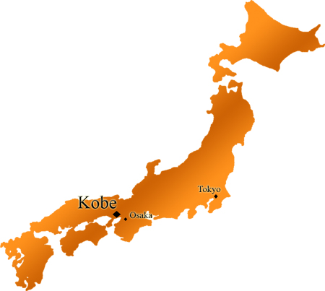  The Kobe Earthquake struck Japan’s most important port, on the western Honshu Island in January 1995. Approximately 6,434 people died as a result of the earthquake, which measured 7.3 on the Richter scale. The earthquake lasted approximately 20 seconds, and caused $200 billion in damage.
Natural Causes | 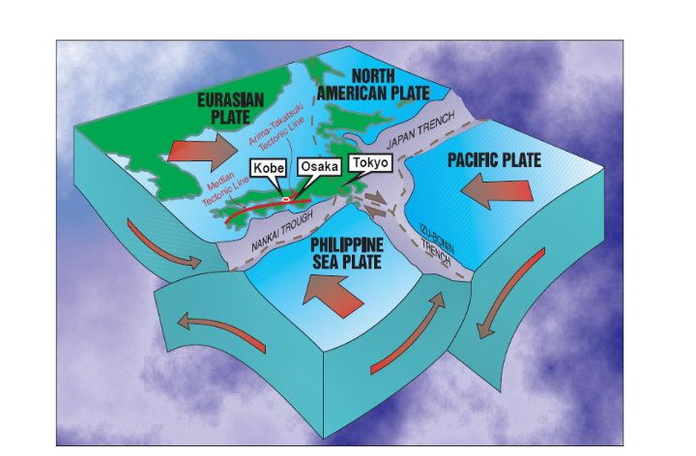  The Phillippine Plate, the Eurasian Plate and the Pacific plate where involved in the earthquake. The fault line was on a destructive plate boundary where the Phillippines Plate suducts the Eurasian plate: a triple plate junction with three subduction zones. The rupture of the fault was somewhere between 30 and 50 km in length. The quake had no foreshocks, and so there was little to no prior warning. Kobe was the city closest to the epicentre, and so experienced the most damage compared to other cities, though aftershocks were experienced along the entire faultline.
Socio-Economic Impacts (including infrastructure) | 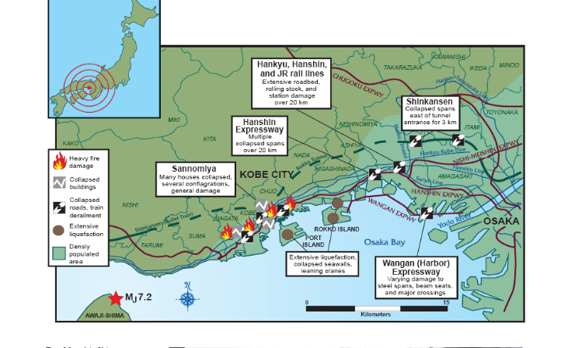  The earthquake caused extensive ground failures, which affected buildings, highways and underground structures: this was caused by liquefaction in heavily developed areas, causing catastrophic building failure. $200 billion in damage was caused, which was approximately 2.5% of Japan’s GDP at the time. This has led to the Guiness Book of Records listing the Kobe earthquake as the "costliest natural disaster to befall any one country." The size and scale of the earthquake caused a severe decline in Japanese stock markets: the Nikkei 225 dropped 1000 points within 24 hours. Large commercial buildings and smaller, traditional Japanese homes accounted for the majority of damage, as their top weight, such as tile roofing, created more lateral force from S-waves than their frames were built to resist. Concrete buildings were mostly resistant up to the fifth floor, where an older version of the code they were built under allowed a weaker superstructure. Transport links were especially affected, including 10 spans of expressway route 43, a major link to Osaka. 70% of regional railway structure was also made inoperable. This all resulted in major economic backlash for the region, as essential transport routes were made redundant, and so recovery from the earthquake was slow.

Information and Issues about relief and recovery | Local hospitals struggled to keep up with demand for medical treatment, as lifeline roads were collapsed and disrupted. This left medical supplies and personnel unable to reach affected areas. Overcrowding and lack of space forced people to wait in hospital corridors for urgent attention. Authoritarian response was so limited that 1.2 million volunteers were involved in the 3 months following the earthquake. Retailers Daiei and Seven-Eleven allowed use of their supply networks to reach affected areas, NTT and Motorola provided free telephone use for victims, and even a Yakuza syndicate distributed food and supplies to needy victims. The national government of Japan was criticised heavily following the earthquake, as they were seen not to have acted quickly enough to save people, and also for their poor management of Japanese volunteers. Japan also initially refused foreign aid from the United States, United Kingdom and South Korea.
Human influences on impact and recovery | Because many buildings were not structurally built to withstand earthquakes, due to older building policies that lacked earthquake protection, both private and public infrastructure suffered greatly. The human decision to build in an earthquake region without having earthquake proof structures or earthquake insurance, meant that the impact of the quake was much greater and the recovery effort much longer than it could have been had planning and prevention forces been more astute.  Due to the destruction of transport links, most of which were destroyed due to the lack of earthquake-proofness that should have been installed by the government, many more people were injured and lost their lives than could have.
Any issues about responses and management | - Japan changed its disaster response policies in the wake of the earthquake. Future earthquakes such as Chuetsu in 2004 had much quicker and effective response times.  - The Ministry of Land, Infrastructure and Transport designated special disaster prevention routes, reinforcing roads and surrounding buildings to keep them intact in earthquake events, and also shelters and supply stores in public parks.  - Food and water supply networks were set up following the earthquake around petrol stations, most of which were not affected by the quake.  - Many citizens groups have resorted to their own disaster plans, after an element of distrust was created in the aftermath of the Kobe earthquake.
Other | - Only 3% of property in Kobe was covered by earthquake insurance, compared to 16% in Tokyo.  - By Cabinet order, in memory of the fires that ravaged the region and the volunteer relief work, January 17, the anniversary of the earthquake, is now Fire Protection and Volunteer Day across Japan.

