Intrusive volcanism – a summary
Landform / structure | Description | Process /notes
Pluton | A pluton in geology is an intrusive igneous rock (called a plutonic rock) body that crystallized from magma slowly cooling below the surface of the Earth. Plutons include batholiths, dikes, sills, laccoliths, lopoliths and other igneous bodies | 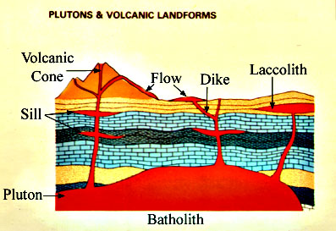
Batholith | A batholith (from Greek bathos, depth + lithos, rock) is a large emplacement of igneous intrusive (also called plutonic) rock that forms from cooled magma deep in the earth's crust. Batholiths are almost always made mostly of felsicc or intermediate rock-types, such as granite, quartz monzonite, or diorite (see also granite dome).
Laccolith | A laccolith is an igneous intrusion (or concordant pluton) that has been injected between two layers of sedimentary rock. The pressure of the magma is high enough that the overlying strata are forced upward, giving the laccolith a dome or mushroom-like form with a generally planar base. | 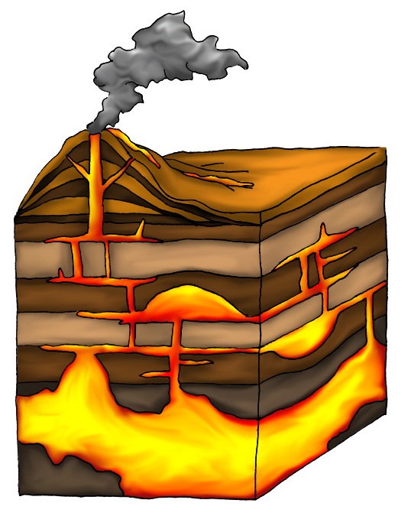
Lopolith | A lopolith is a large igneous intrusion which is lenticular in shape with a depressed central region
Dike (or dyke) | A dike or dyke in geology is a type of sheet intrusion referring to any geologic body that cuts discordantly across the country rock or existing structures | 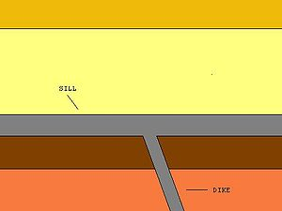
Sill | A sill is a tabular pluton that has intruded between older layers of sedimentary rock, beds of volcanic lava or tuff, or even along the direction of foliation in metamorphic rock. The term sill is synonymous with concordant intrusive sheet. This means that the sill does not cut across pre-existing rocks, in contrast to dikes which do cut across older rocks.
Country Rock | Country rock is a geological term meaning the rock native to an area. when describing a pluton or dike one may describe the igneous rock as intruding the surrounding country rock, the rock into which the pluton has intruded.
Metamorphic contact zone | Contact metamorphic rocks are found in aureoles, zones of metamorphic rock surrounding and associated with plutons.
Conduit | A vertical or sub-vertical tunnel which links the magma chamber to surface vents in a volcano
Xenolith | Literally ‘foreign rock’. Generally, these are parts of the mantle that have become carried into the magma chamber and occasionally extruded on to the surface or reveal by later erosion. Almost exclusively used to describe inclusions in igneous rock during magma emplacement and eruption
Stock | In geology, a stock is a discordant igneous intrusion having a surface exposure of less than 60 km2, differing from batholiths only in being smaller. Most stocks are probably the cupolas of hidden batholiths. Circular or elliptical stocks may have been vents feeding former volcanoes. | 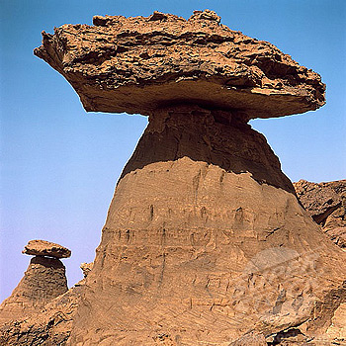
Tor | The weathered tops of stocks that form part of a batholiths. They form exposed rock masses of jointed and broken blocks. Tors are seldom more than 15 metres high and often occur as residues at the summits of inselbergs and at the highest points of pediments. Tors usually overlie unaltered bedrock and are thought to be formed either by freeze–thaw weathering or by groundwater weathering before exposure. | 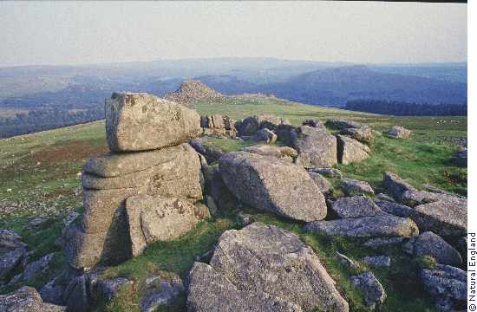
Inselberg | an isolated rock hill, knob, ridge, or small mountain that rises abruptly from a gently sloping or virtually level surrounding plain | 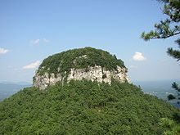
Vein | A distinct sheet like body of crystallized minerals within a rock. Veins form when mineral constituents carried by an aqueous solution within the rock mass are deposited through precipitation. The hydraulic flow involved is usually due to hydrothermal circulation. | 