Tectonic landforms – fold and fault systems – a summary
Landform / structure | Description | Process /notes
Faults  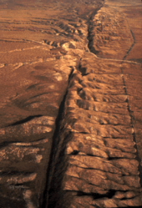  The San Andreas Fault, a right-lateral strike-slip fault caused the massive 1906 San Francisco earthquake | The outer part of the Earth’s crust is relatively cold and brittle. When the crust becomes stressed, faults (weaknesses) occur. These are generally linear and occur at plate boundaries. Faulting can also occur in the middle of plates, often in extinct orogenic belts or old plate boundaries. Faulting occurs in the top 10 to 15km of the Earth’s crust.  Normal faults occur where there is tension – where the earth is stretching. With normal faults, the hanging wall moves downwards along a steep plane – the exposed face is known as the fault scarp.  The Greek mainland and islands are full of normal faults where the crust is ‘flowing away’ from the Alpine collision zone.  Reverse faults occur where there is compression and are common in fold mountains and convergent plate margins. The hanging wall moves upwards.  Normal and reverse faults are called dip-slip faults – movement occurs along the dip plane. | 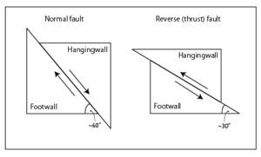  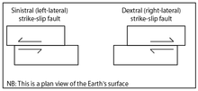
Mountain building and orogeny | Orogeny refers to forces and events leading to a severe structural deformation of the Earth's crust due to the engagement of tectonic plates. Response to such engagement results in the formation of long tracts of highly deformed rock called orogens or orogenic belts. It is the primary mechanism by which mountains are built on continents. Orogens develop while a continental plate is crumpled and thickened to form mountain ranges, and involve a great range of geological processes collectively called Orogenesis.  Mountain formation refers to the geological processes that underlie the formation of mountains. These processes are associated with large-scale movements of the earth's crust (plate tectonics).The formation of mountain ranges occurs by means of lateral movements as opposed to vertical ones. Mountain formation is related to plate tectonics. Folding, faulting, volcanic activity, igneous intrusion and metamorphism are all parts of the orogenic process of mountain building. The understanding of specific landscape features in terms of the underlying tectonic processes is called tectonic geomorphology, and the study of geologically young or ongoing processes is called neotectonics. | 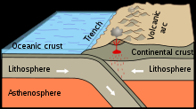  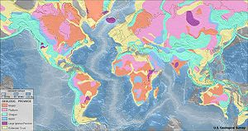
Fold mountains | Fold mountains are generally formed in the less deformed areas adjacent to areas strongly affected by thrust tectonics. Typically they are found in the foreland region where a major mechanically weak decollement horizon is present. The frontal thrust (or thrusts) propagate(s) a long distance along this horizon and subsequent movement on the thrust can give rise to a sequence of folds as the hanging wall of the thrust effectively crumples. The anticlinal crests may be high enough to form mountains. Most fold mountains are likely to be relatively young in geological terms as they will start to be eroded as soon as they are formed. | 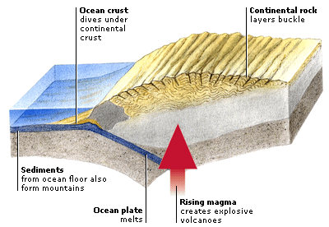  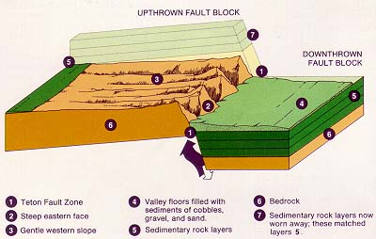  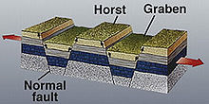
Fold-thrust belt | A fold and thrust belt is a series of mountainous foothills, adjacent to an orogenic belt, that form due to compression. Fold-thrust belts commonly form in the forelands adjacent to major orogens as deformation propagates outwards. Fold and thrust belts usually comprise both folds and thrust faults, commonly interrelated.
Fault block mountain – rift valleys and rift systems | Fault-block landforms (mountains, hills, ridges, etc.) are formed when large areas of bedrock are widely broken up by faults creating large vertical displacements of continental crust. This is generally where the there is tension in the crust and the crust is thinning. Vertical motion of the resulting blocks, sometimes accompanied by tilting, can then lead to high escarpments. These mountains are formed by the Earth's crust being stretched and extended by tensional forces. Fault block mountains commonly accompany rifting, another indicator of tensional tectonic forces.  The uplifted blocks are called block mountains or horsts. The intervening dropped blocks are termed graben: these can be small or form extensive rift valley systems. This form of landscape can be seen in East Africa, the Vosges, the Basin and Range province of Western North America, in south-central New England, and the Rhine valley. These areas often occur when the regional stress is extensional and the crust is thinned.  Two types of block mountains are lifted and tilted. Tilted type block mountains have one gently sloping side and one steep side with an exposed scarp, and are common in the Basin and Range region of the western United States. Level blocks lead to the horst and graben terrain seen in northern Europe. Lifted type block mountains have two steep sides exposing both sides scarps.  Some rift systems are ancient and are no longer active – such as the Vosges and New England – whereas others are still very active – such as the African Rift Valley and mid-ocean ridges.
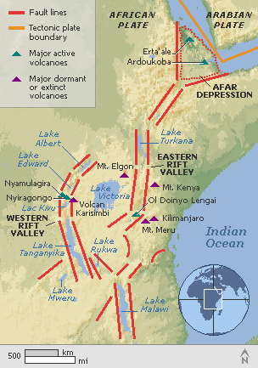  The East African Rift  Valley | The Great Rift Valley is a name given in the late 19th century by British explorer John Walter Gregory to the continuous geographic trench, approximately 6,000 kilometres in length, that runs from northern Syria in Southwest Asia to central Mozambique in East Africa. The name continues in some usages, although it is today considered geologically imprecise as it combines features that are today regarded as separate, although related, rift and fault systems. Today, the term is most often used to refer to the valley of the East African Rift, the divergent plate boundary which extends from the Afar Triple Junction southward across eastern Africa, and is in the process of splitting the African Plate into two new separate plates. Geologists generally refer to these incipient plates as the Nubian Plate and the Somali Plate.  In simple terms, a rift can be thought of as a fracture in the earth's surface that widens over time, or more technically, as an elongate basin bounded by opposed steeply dipping normal faults. Geologists are still debating exactly how rifting comes about, but the process is so well displayed in East Africa (Ethiopia-Kenya-Uganda-Tanzania) that geologists have attached a name to the new plate-to-be; the Nubian Plate makes up most of Africa, while the smaller plate that is pulling away has been named the Somalian Plate (Figure 1). These two plates are moving away from each other and also away from the Arabian plate to the north. The point where these three plates meet in the Afar region of Ethiopia forms what is called a triple-junction. However, all the rifting in East Africa is not confined to the Horn of Africa; there is a lot of rifting activity further south as well, extending into Kenya and Tanzania and Great Lakes region of Africa. The purpose of this paper is to discuss the general geology of these rifts are and highlight the geologic processes involved in their formation.  It is a very rare example of a divergent margin on continental crust. Where tension has occurred, the crust has thinned creating volcanism. Inward facing (normal faults) tower 600mm above the valley floor (the graben). | 